Kilsture Forest Community Group

Developing our role as co-custodians of the forest

Final Report to Future Woodland

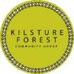

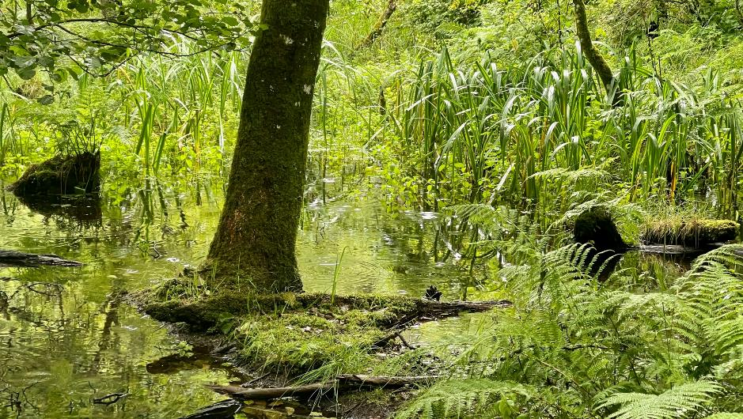
Kilsture Forest Wetlands photo credit: Ted Leeming

Contents
- Background
- Aims of project
- Timetable
- Summary of Activities
- Outputs / outcomes
- Dissemination
- Conclusion / next steps

BACKGROUND
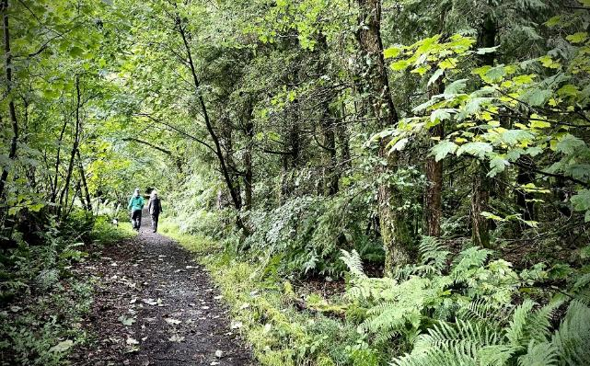
Kilsture Forest Dog Walkers photo credit: Ted Leeming
Kilsture Forest is a 204-hectare, 80-100 year-old mixed-woodland plantation which lies at the heart of The Machars in Galloway surrounded by agricultural land.
Kilsture Forest Community Group (KFCG) came together in 2018 when Forestry & Land Scotland (FLS) announced plans to dispose of parts of its estate, including Kilsture Forest. The prospect of losing this much-loved woodland to private ownership sparked local action, and KFCG was formed to give the community a voice. Through careful research and determined advocacy, the group were able to demonstrate that FLS’s criteria, that prioritised visitor numbers, disadvantaged smaller rural communities. As a result, Kilsture was removed from the disposal list, and subsequently FLS invited KFCG to take an active role in forest management through the Community Agreements framework.
In 2021, as lockdown restrictions lifted, volunteers began restoring the forest’s paths and clearing invasive species — our first step in partnership with FLS which demonstrated our commitment and willingness to get involved.
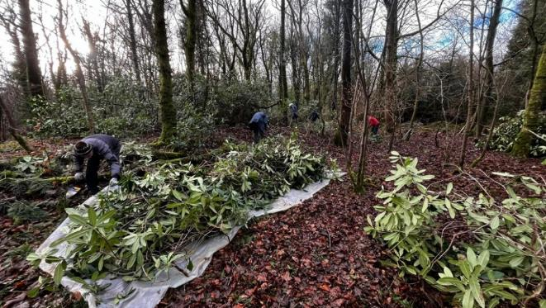
Rhododendron clearing photo credit: KFCG
FLS from the start encouraged us to progress up to a Memorandum of Understanding (MoU), so formalising our role representing community interests in long-term forest management. But initially it was not clear what an expanded role in woodland management would look like.
A turning point came during a site visit when an FLS forester acknowledged that “no-one knows what’s in here,” signalling a role for the local community to record and survey the forest ecology. We would gather the locally held knowledge, which we knew existed, and add to that with new efforts, to build a baseline understanding of what lives in the forest.
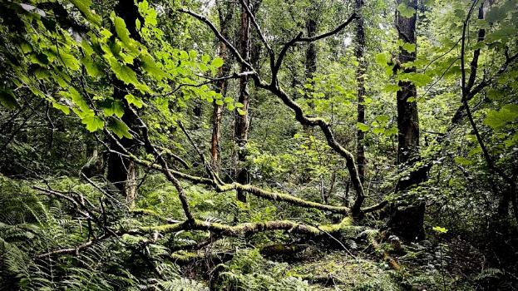
Kilsture Forest Wetlands photo credit: Ted Leeming
KFCG secured funding from Future Woodlands to launch a citizen science programme in 2023, launching a programme of community-led recording of Kilsture’s biodiversity. The formal signing of the MoU in 2024 cemented a collaborative relationship, centred on shared objectives “to manage the natural systems of the woodland through data collection to better understand forest ecosystems and how these could contribute to woodland management.”

AIMS OF PROJECT
We set out to build community capacity and develop our joint working with FLS, to put the community on a good footing for long term custodianship of the woodland. To this end we carried out a programme of activities to:
- better understand the forest ecosystem - collate and digest existing information
- gather new information to underpin the particular concerns / interests community has
- better understand FLS’s and other approaches to woodland management and how KFCG can interact with these.
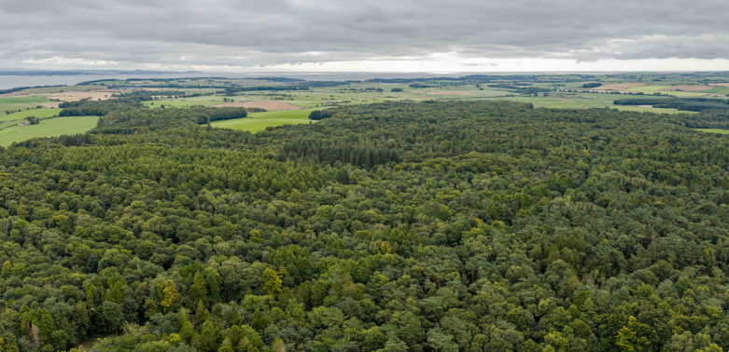
Image from Drone Survey carried out as part of funded activities. August 2025 photo credit Angus Mackie.

TIMETABLE
It is important to add a note on timing at the start of this report. Originally the funded programme was planned to run from May 2023 to April 2024, however the project timeline was extended, thanks to Future Woodlands’ flexibility.
The delay was mainly due to the small window available for the drone survey which has to be conducted in calm, dry weather when the canopy is in full leaf in August ideally, after the bird breeding season is over and before the leaves start to turn.
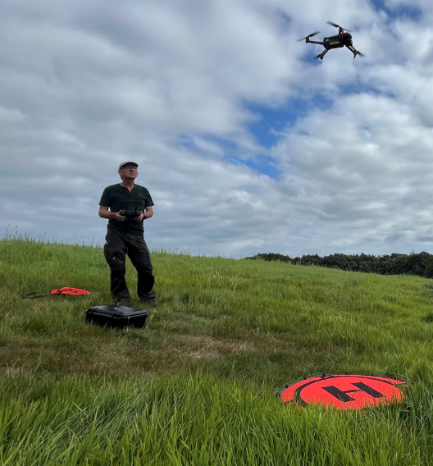
Drone pilot Angus Mackie photo credit KFCG
We missed that window altogether in 2023 due to poor communication; August of 2024 brought weeks of rain and high winds which made a survey impossible and the survey happened in August this year. This meant we experienced the realities of working both with the forest’s natural rhythms and the uncertainties of the weather - two very important lessons.

SUMMARY OF FUNDED ACTIVITIES
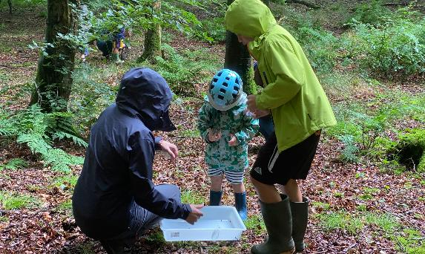
Kilsture Forest Family Day photo credit KFCG

Setting up the Kilsture Forest ‘Project’ on iNaturalist
To set up our recording project, SWSEIC created a Kilsture Forest ‘Project’ on iNaturalist, which means that all data recorded in Kilsture are logged and displayed here. As well as creating a vibrant presentation of species abundance in the forest. it has a list of recorders ranked in order of who has collected the most records. We have a standout leader in the field - local resident who records under the name ‘Umbramus’ has made 234 recordings to date.

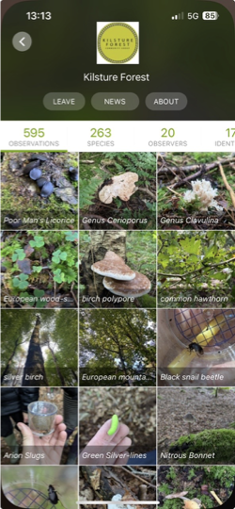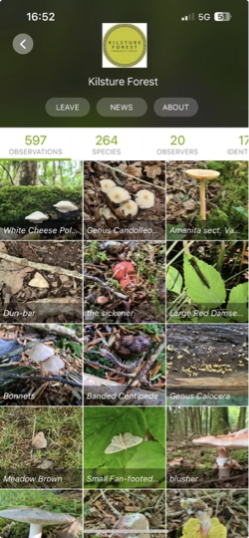

The almost magical thing about iNaturalist is that this impersonal digital interface is directly connected to two very real humans who are SWSEIC – Mark Pollitt and Malcolm Haddow. They are integral to all our recording activities, materialising regularly to run training and species identification sessions in the forest and crucially they manage the database for all records held on Kilsture. This year, with a grant from Inspiring Scotland Neighbourhood Ecosystem Fund, they have created an interactive digital map of the ecosystem of Kilsture which plots all the species so far recorded in the forest to be used primarily to inform environmental impact assessment relating to woodland management plans.

Photo gallery of workshops
How to use iNaturalist – Kilsture Forest, led by Malcom Haddow - then with Galloway and South Ayrshire Biosphere - 18th June 2023
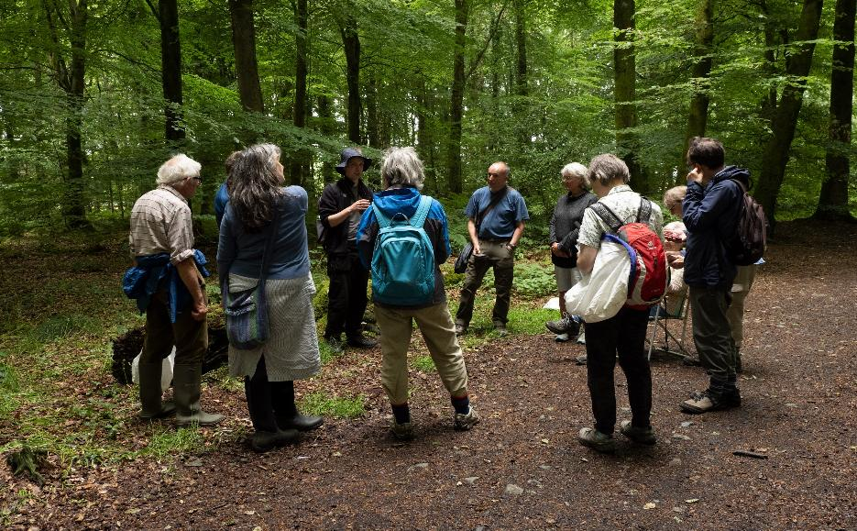
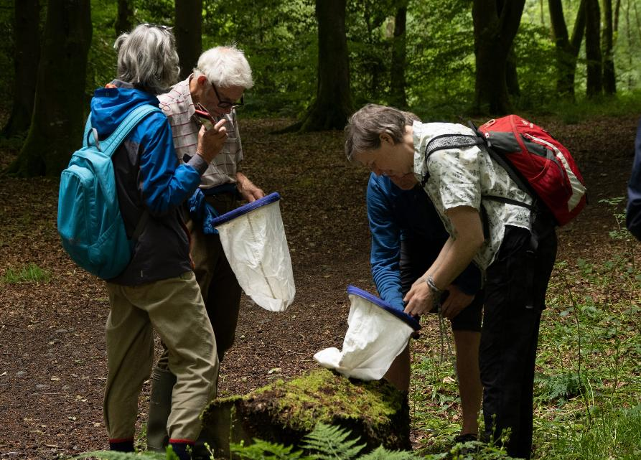

Family Day 1 July 5th 2023 – with Galloway and South Ayrshire Biosphere
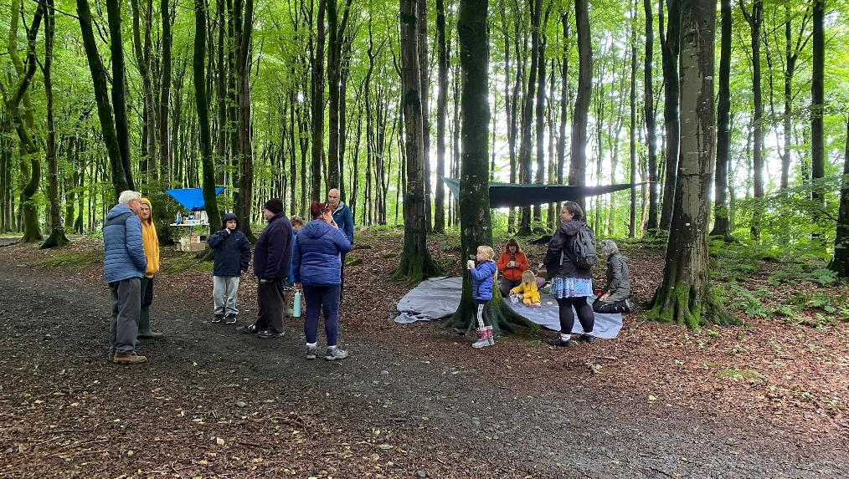

Family Day 2 with South West Scotland Environmental Information Centre – 5th August 2023
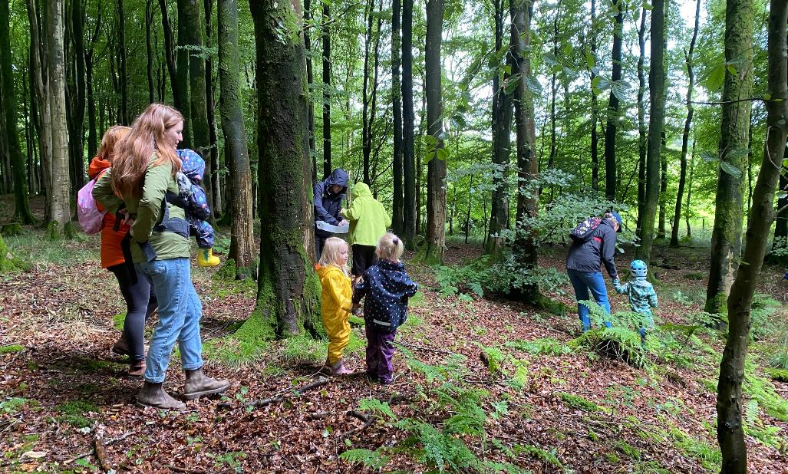

4.3 Bat walk with South West Scotland Environmental Information Centre 9th September 2023
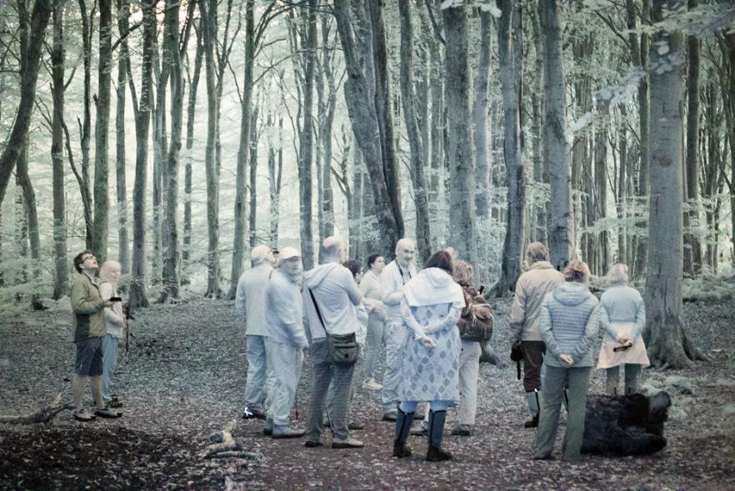

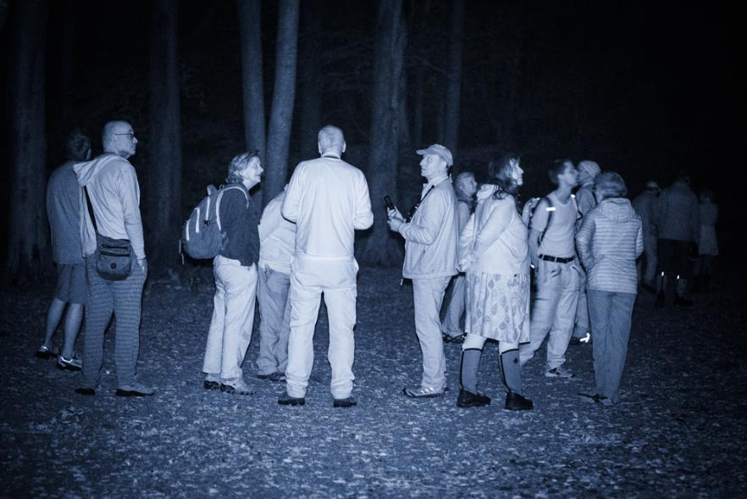
Night photography by Ted Leeming

4.5 Fungi iD workshop with South West Scotland Environmental Information Centre 8th October 2023
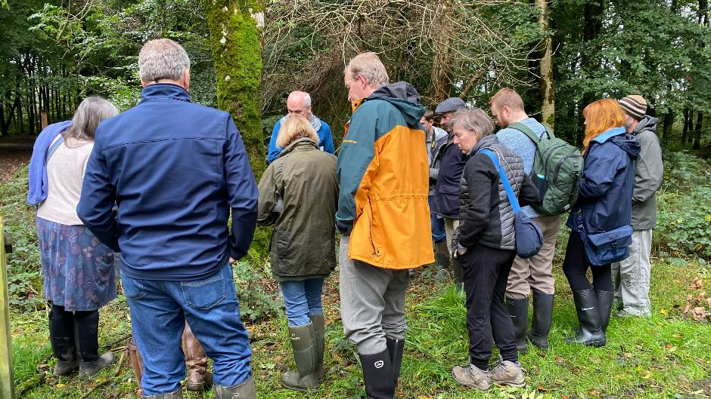

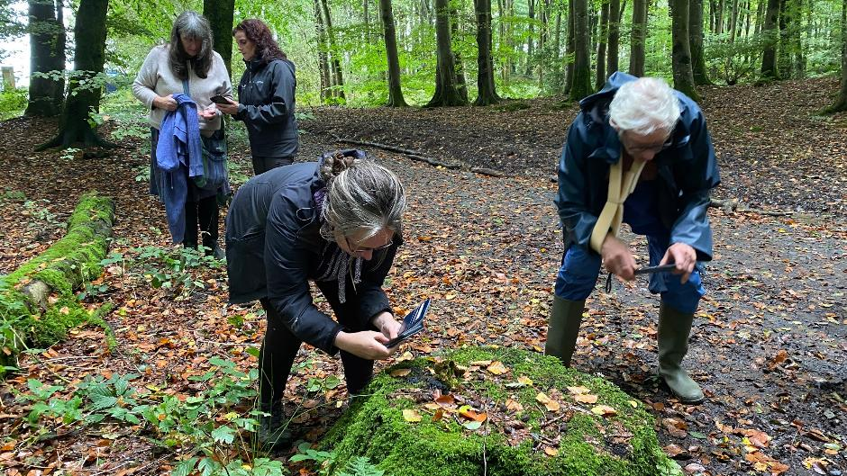

In addition to the sessions in the forest, we also presented three indoor community facing events: a lecture by Peter Norman and Malcolm Haddow on the History and Landscapes of Kilsture to a full house in January 2024 in Whauphill Village Hall (no pictures); a chromatography workshop introducing the basics of making soil chromatograms and what they can tell us about the soil in Kirkinner Village Hall in March 2024 and our Mycorrhizae Symposium in Wigtown County Buildings in May 2024, attended by 46 people.
4.6 Chromatography Workshop October 23rd 2023
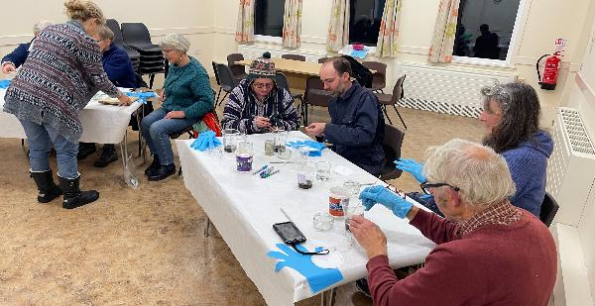
4.7 Mycorrhizae Symposium 4th May 2024
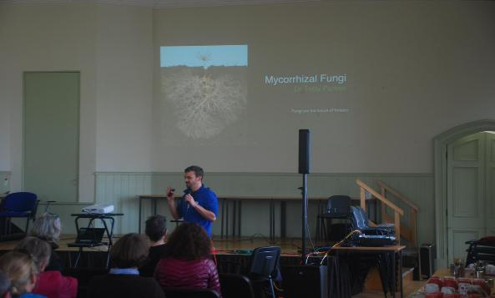
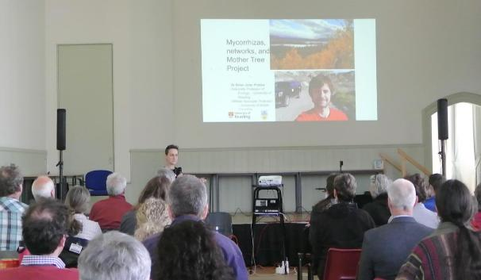

4.8 Finally, some images from the drone survey footage – August 145h – 15th 2025
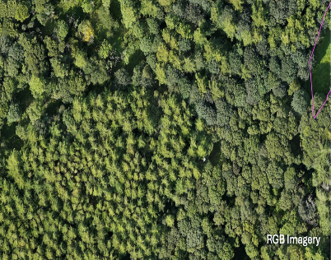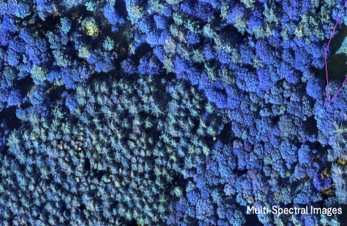

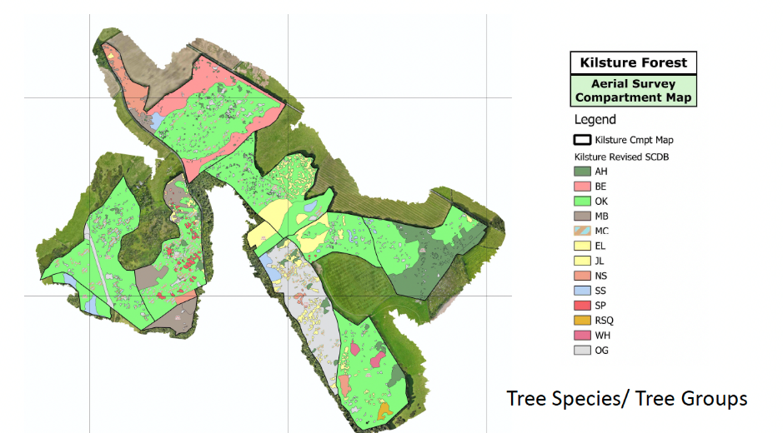

OUTPUTS AND OUTCOMES
A positive outcome of the programme being delayed is having the rare opportunity to report on the project itself and the legacy that emerged from it. We can now view our citizen science programme as a continuum—beginning with the Future Woodlands–funded phase in 2023–24, developed by the 2025 programme (funded by Inspiring Scotland) which evolved directly from the first and has pointed the way to future developments. As laid out below every activity that we staged as part of this funded programme had a natural legacy, so demonstrating its effectiveness in delivering on our aims for the programme

Citizen Science Programme Outputs in numbers
- 8 community engagement events
- 156 participants/attendees across all events
- 7 chromatograms created
- 4 – 81 age range of participants
- 20 iNaturalist observers (2023 – 25)
- 275 species recorded on iNaturalist (2023 – 25)
- 1st ever community commissioned Mycorrhizae Symposium
- 1 portfolio of images and maps + analysis from drone survey
- 6 blogs on kilstureforest.org (published in 2024)
  - Introducing Kilsture Forest’s Citizen Science Programme here
  - Citizen Science – the first 12 months here
  - KFCG’s Mycorrhizae Symposium here
  - Looking back at 2024 here
  - Forest School in Kilsture here
  - Art | Science | Forest R& D here
- 340 blog views
- 680 fb followers (up by 120) since start of project
- 4 new trustees since start of project
- £55K new funds raised for activities since start of project

Citizen Science Programme Outcomes
5.2.1 Recording wildlife At our 2024 AGM, Malcolm Haddow (SWSEIC) shared a presentation on the first year of our Citizen Science Programme. He emphasised the importance of recording and submitting all wildlife sightings, explaining that until data reaches SWSEIC, a species is effectively absent from the scientific record. Now that we have built confidence in “casual recording”, Malcolm encouraged us to move towards more structured surveys to fill gaps and monitor seasonal change. Taking this advice forward, we have launched “Monitoring Mondays” — monthly volunteer sessions focused on targeted species recording and long-term ecological monitoring through our woodland condition assessment programme - see below.
5.2.2 Mycorrhizae Symposium The symposium offered a fascinating insight into the science of mycorrhizal networks and their vital role in supporting healthy, resilient forests. Understanding plant soil interaction is key to sustainable woodland management. FLS is now carrying out long-term research—over 30 to 40 years—on mycorrhizal fungi, soil, and forest management techniques, despite commercial pressures and future market uncertainty. In an informal workshop, participants discussed how these findings could help address local issues, from bird habitats to peatland restoration.
In addition to the stimulating content, we were delighted that as a newcomer woodland community group we had managed to attract a stellar group of speakers and was asking a question that was interesting to a lot of people from across the region, working in different aspects of environmental sustainability. We also made lasting connections with groups and individuals with shared interest and so developed adding to our capacity and reach locally and regionally. See below for more on partnerships.
5.2.3 Drone Survey
The drone survey was undertaken to capture both high resolution photographic aerial imagery and multispectral imagery (i.e. near infra-red, red, red edge and green) to establish the composition of the forest in terms of the broadleaf/coniferous ratio, specific tree groups and some individual tree species.
Advance contact was made with all the surrounding farm landowners for permission to use their land as take-off and landing zones. Some, along the south and south west refused permission due to the presence of livestock (concerns that the drone would spook the cattle and the livestock themselves be a H&S risk to the drone pilot). As a result, 135Ha of the 204Ha was flown and recorded. The maximum legal flight distance is 500m requiring constant visual sight with take-off/landing from an open area. Some areas of the forest were therefore in excess of 500m from a suitable take-off zone.
The start point for the analysis was to download a copy of the FLS Sub Compartment Database (SCDB) from the Open Forest Inventory Data. The SCDB for Kilsture was then clipped to the extents of the drone survey.
KFCG itself does not have access to GIS software, so a series of map outputs showing the woodland compartment structure have been provided for our own use, including the original SCDB and the updated SCDB. These have been produced at A0 size to provide the maximum detail.
The small scale distribution of species and species mixtures has meant that many of the mixtures have been separated where possible. In some cases, individual trees have been identified but in most cases, it’s the separation of mixtures which has been the key output from the analysis. One of the key outputs has also been the separation of conifer and broadleaf. Diseased Ash (or assumed diseased Ash) has been identified throughout. Open areas and gaps in the forest canopy have also been mapped.
There is a final piece of work relating to the drone survey pending. We would like to ask Angus Mackie to present his findings to an online gathering of KFCG trustees, members and other interested people, so that we can understand the results of the survey in lay-person’s language. We will organise this to happen over the coming months.
5.2.4 Partnership Building is key to us developing our role as co-custodians of the forest. Through them we bring additional capacity, expertise and inspiration to our partnership with FLS.
- FLS - as our primary partner, the key to this is for us to be able demonstrate competence and that we add capacity and value to the partnership and to build trust. As a result of our citizen science programme we are now acknowledged as the biodiversity lead in the relationship.
LEGACY: just under a year after we started this programme we signed an MoU with FLS to formalise our role as representing the interests and priorities of the community in planning decisions. By the terms of the MoU we meet up to 4 times a year to discuss issues relating to woodland management of Kilsture, guided by the objectives that we came up with FLS: “to manage the natural systems of the woodland through data collection to better understand forest ecosystems and how these could contribute to woodland management”. From these meetings we have been able to find out more about FLS approach to woodland management, their priorities and their constraints.
There is planned thinning work for the second half of the Plan timeframe (2028-2033) and FLS has invited us to submit names of contractors to undertake this work, specifically for a small test area of thinning to take place this winter. We have therefore been able to explore various different approaches to thinning and extraction, and are very keen to introduced Continuous Cover Forestry into Kilsture’s management. Some of the trustees are currently undertaking an online, accredited, introductory course in CCF.
- SWSEIC have been central to the delivery and direction of our citizen science programme. After the first 12 months of the programme they gave a presentation of all that we had achieved at our AGM. Whilst there was lots to celebrate they also pointed to big gaps in the species recorded. See blog above.
- LEGACY: We raised funds for a second phase of Citizen Science activities with Kilsture1000 a successful challenge to record more species and boost the numbers of citizen recorders involved. SWSEIC is now developing a unique interactive digital map of Kilsture’s ecosystem as a key communication tool informing our planning work with FLS.
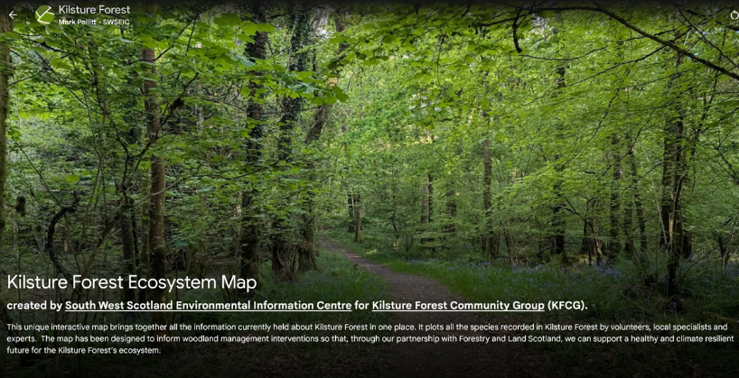
Here is a link to the digital map

SWSEIC Manager Mark Pollit says: "It's great to see a community batting on the side of biodiversity. KFCG is proactive, well-organised and leads the way in gaining involvement from the community to contribute to a fuller understanding of the forest."
- Dr Petra Guy, who gave a fascinating presentation about her work at the cutting edge of her research into plant-soil interaction at the Mycorrhizae Symposium, immediately became an invaluable ally in helping us develop our understanding of forest ecology. Her enthusiasm for our work from the start has given us confidence that we were going in the right direction: “KFCG has understood the importance of addressing woodland health and biodiversity in a holistic manner. The group is harnessing their local knowledge and passion for the site to build understanding of the woodland as a fully connected functioning ecosystem.”
LEGACY: In 2025 Petra, with her PhD student Julija Fediaviate has since created a bespoke Woodland Condition Assessment protocol for Kilsture, taking account of its multiple woodland habitat types, carried out by our volunteer citizen surveyors this summer.
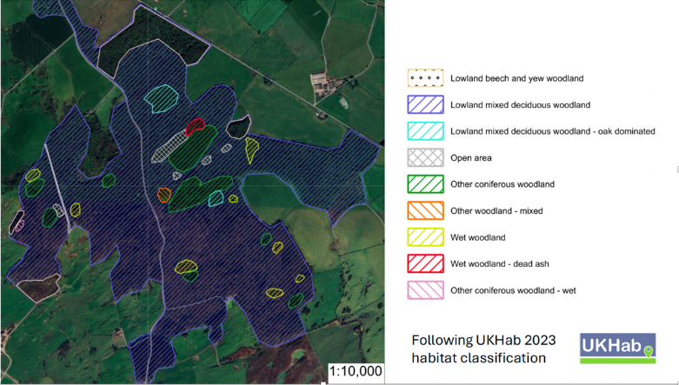
Sketch map of Woodland Habitat types in Kilsture
By observing the natural processes that drive the forest ecosystem: plant and soil interaction, regeneration and decay, the rate of water flowing through the forest, our community is becoming attuned to the indicators for of forest health and how these inform management for biodiversity.
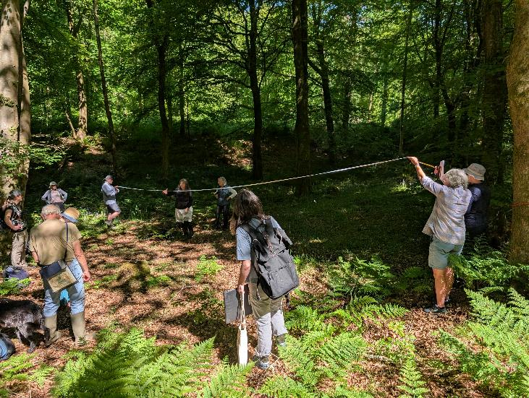
Woodland condition assessment – measuring out a 10m2 plot for recording and monitoring during training.
Petra is also the scientist in our interdisciplinary Arts | Science | Forest research project team. We connected with the other two members of the A | S | F team, artist Morag Paterson and forester Andrew Macqueen, directly as a result of these first phase citizen science programme activities.
- Galloway and South Ayrshire Biosphere (GASB) again another enthusiastic and supportive partner who have continued to support our activities. We have participated in their Green Fayre events since 2023.
- LEGACY As a direct result of this programme we were invited to be part of their Sustainable Development Goals Trail which means we have a QR code and marker at the entrance to the forest which links to SDG 15 – Life on the Land

5.2.5 Working with children and young people
Family days: We are committed to developing future generations of forest custodians and reaching young people and children was a key goal of this programme. Our two family days were very well attended with children aged 4-10. However we know that not all children have the opportunity to come to this type of event and we wanted to do more. In parallel with the citizen science programme we started doing some research into setting up Forest School in Kilsture – the dream being that we could find a way of reaching every child in the Machars during their primary education.
LEGACY: Following a feasibility study carried out in 2024, KFCG is providing Forest School to six local primary schools as part of the school day and are planning to extend this to a Junior Rangers in secondary school. The children are now contributing to our wildlife recording projects and recently caught footage of a hare and two different types of mouse on their trail camera, all as yet un-recorded species in Kilsture, as well as lots of different types of fungi.

Young People: The symposium attracted more young people in 20-30, than our other events, in particular two young ecology graduates who had just moved into the area and were very interested in the work of KFCG. One of them has since joined the board as a trustee and another, newly qualified as a forest school leader, is now running our Forest School Programme. We have since welcomed another young person onto our board who volunteers for the local brownies and guides and is building connections to the forest with both these groups.

DISSEMINATION
In our application, we laid out plans to share and disseminate our findings widely within the original time frame of the grant 2023-24. While we were able to share our work in those first two years, it is definitely out there now, thanks to the early foundations laid and subsequent development of our programme.

2023: In July 2023, on the recommendation of Andy Rockall, CEO, Community Woodlands Association, Chris Blake forester/land manager/mature Masters Student from Bangor University, approached us to feature as one of four case studies (2 in Wales, 2 in Scotland) in his research paper looking into community land stewardship and the delivery of public goods. He lists the following benefits to define public goods: Farmland and forest biodiversity - Soil functionality - Air quality - Agricultural & forest landscapes - Water quality and availability - Climate stability - Resilience to flooding & fire - Rural Vitality
Here is an extract from the conclusion he draws from the research:
UK governments, under international commitments to biodiversity and climate change, have incorporated the principles of multi-functional forestry into policy and legislation requiring the managing agencies to deliver across a broad range of public goods. But this diversification of forest management priorities has coincided with reductions in funding resulting in the outsourcing of front-line operations and a reduced and more centralised management. The cumulative effect has been a loss of “boots, “ears” and “eyes” from the forest weakening the link between foresters and communities and under-delivery of some public goods. At the same time some communities have been seeking to play an increased role in forest management and a range of models of community stewardship have been developed from ownership (significantly in Scotland), to long-term management agreements, co-design, and informal partnerships – each representing a degree of power transfer from the public to the community organisation…
…Community forest stewardship does enhance the delivery of public goods from the human and financial resources that community stewards bring to the task when compared with resource constrained public stewards. Finding ways to unlock the power community forest stewardship is an important to meet the climate, nature, and social challenges we face.
2024: We were encouraged by our first years’ activities and the number and range of attendees from across the forestry and environmental sector at our Symposium, indicated that we were able to engage a wider audience in our work. However, this year, with another year’s activity under our belt funded by Inspiring Scotland’s Neighbourhood Ecosystem Fund, our work has come to the attention of a number of local and national organisations.
2025: We have been invited by the following organisations to share our experiences:
- Community Woodlands Association (CWA): Presentation of our work at their annual conference. 25-26 September 2025
- Forestry Policy Group: Podcast with Julia Farrington (Co-Chair KFCG) October 27 2025
- West Stormont Woodland Group: Online presentation of our work to the board of this community woodland group, at the invitation of one of their trustees who attended the CWA conference. 28th October
- Scottish Landscape Alliance: A case study of our work featured at SLA’s Landscape Charter Action Planning event. 30 October 2025
- Scottish Community Alliance (SCA): CWA invited us to submit a case study of our work to CWA’s new campaign, Power in our Places, designed to showcase the strength and value of Scotland’s community sector
- D&G Woodlands: will co-host an online session entitled Future Forest Watching with KFCG’s Art | Science | Forest trio discussing how they manage the pressures of climate and biodiversity crisis in their work. 3 Feb 2026
- Reforesting Scotland: Julia Farrington has been commissioned to write an article for the Community Woodlands section of the Spring/Summer 2026 edition of the magazine
- Community Land Scotland’s Natural Capital Community Partnership: Their partnership advisor has reached out to us, via a contact from FLS, to contribute a case study for their programme.
- Linking with local community woodlands: Balloch Wood, Cairsphairn and Taliesin are the closest woodlands to Kilsture and we are beginning to connect over issues of mutual interest.

CONCLUSION/NEXT STEPS
The citizen science activities funded through the Future Woodlands grant have created a very strong, inclusive foundation for our work in Kilsture, and everything we are now doing has evolved directly from them. The development of our citizen science programme has shown the real value of being in a management agreement with Forestry & Land Scotland (FLS). Instead of having to shoulder the practical liabilities and financial burden that direct land ownership brings, we are free to harness the community’s energy and love for the forest to becoming informed and engaged co-custodians. We are now in an exciting position where our work is being recognised as innovative and offering a model for how community-led initiatives can contribute to achieving Scottish Government’s biodiversity targets.
The drone survey has provided KFCG with significant useful survey data over a wide area that we can utilise as part of our ongoing data collection for the forest. It will assist us with detailed habitat identification through the tree groupings and species identified and assist our discussions with FLS on Continuous Cover Forestry and thinning proposals. It identifies many more additional areas affected by ash dieback that we can utilise as part of our resilient ash survey and saves us valuable hours of footwork on the ground.
It’s perfectly possible that some of the species identification may not be an exact match for what is on the ground, so there is scope for ground truthing of current results and updating of species and mixtures based on a ground truthing exercise. This is something that the Kilsture volunteering community can undertake as part of our ongoing citizen science project.
In addition to following up on the drone survey outputs, our next step, as agreed by our membership and FLS, is to build on Galloway Fisheries Trust (GFT) survey of Kilsture’s wetlands and watercourses which took place in April 2025. Their findings highlighted both healthy and degraded sites and revealed that the forest’s natural water flow has been reversed, with negative impacts on biodiversity.

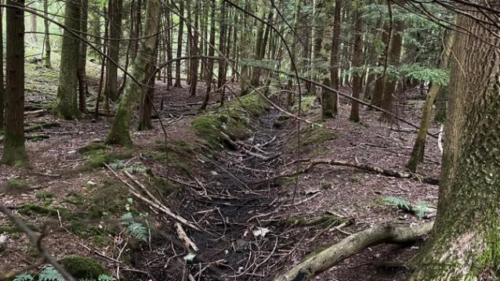
Blocked ditches part of the degraded drainage system in the forest
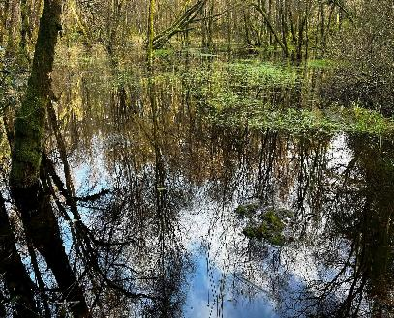
Wetlands in the forest during winter – the challenge is how to maintain the water level throughout the year

In response, we plan to raise funds for a participatory feasibility study into wetland restoration. Working alongside GFT, volunteers will collect various data associated with the site’s hydrology and soil samples across the estate including soil samples, while developing new understanding of the impact of raising and lowering the water table on the forest itself and neighbouring land. If, at the end of the feasibility study, GFT’s recommendations meet all the necessary regulations, this project could mark a major step forward—our first move into habitat restoration in Kilsture.

