PROGRESS REPORT – August 2025
Mycoviruses infecting the pine tree pathogenic fungus Dothistroma septosporum

Our PhD student, Josephine, is now into her second year of her PhD studies having successfully completed her first progress assessment in early 2025. During her first year of PhD studies, Josephine was being supported by Future Woodlands Scotland as well as the Whitaker Trust (£5K each). Her tuition fees have been waived, and the remainder of the funding in her first year was provided by a studentship from the Centre for Agriculture, Food and Environmental Management Research (CAFEM) at the University. We would be very grateful for continued support of Josephine’s studies as she moves into her second year, alongside the CAFEM studentship.
The work on mycoviruses in D. septosporum is performed in collaboration with Forest Research (FR) UK. Josephine has visited FR three times since March 2025 and is scheduled to visit once more before the beginning of the new academic year.

In terms of progress so far, Josephine has focused on five main tasks:
- Designing oligonucleotide primers for mycovirus diagnostic assays.
- Screening new D. septosporum isolates in collaboration with FR.
- Initiating a pathogenicity trial on pine saplings in collaboration with FR.
- Reviving an old collection of D. septosporum isolates.
- Contributing towards a manuscript on D. septosporum mycoviruses.

- Dothistroma septosporum chrysovirus 1 (DsCV-1) is the first mycovirus found in D. septosporum (Shah et al., 2023 Arch Virol 168(5):144. doi: 10.1007/s00705-023-05768-9). A molecular diagnostic assay for DsCV-1 infection had been developed in the laboratory and was available before Josephine initiated her PhD. However, 13 additional mycoviruses were discovered in Dothistroma isolates from Austria, Czech Republic, Ireland, Italy, and Slovenia (Trifković et al., 2024 Virus Res 350:199476. doi: 10.1016/j.virusres.2024.199476), whose genomic sequences have been deposited in public databases. Josephine used the Primer-Basic Local Alignment Search Tool (BLAST) on the National Institute for Biotechnology Information (NCBI) to design 13 pairs of oligonucleotide primers based on these genomic sequences for molecular diagnostic assays (Table 1). All pairs were tested on synthetic constructs as a positive control and water as a negative control in one-step reverse transcription and quantitative polymerase chain reaction (RT-qPCR) diagnostic assays and were found to perform satisfactorily.
Next steps: none, task completed.

Table 1: Oligonucleotide primer pairs for RT-qPCR diagnostic assays of Dothistroma mycoviruses.
Mycovirus | Primer name | Sequence (5'-3') | Length (nt) | Amplicon size (bp) | GC (%) | Tm (°C)
DsCV2 | JB_Chryso 1_RdRp_FW | AACGCAACGCTTGATTTGCT | 20 | 240 | 45 | 59.97
DsCV2 | JB_Chryso 1_RdRp_RE | TTCAGCGTTGCTATTGGGGT | 20 | 240 | 50 | 59.96
DsCV3 | JB_Chryso 2_RdRp_FW | ATACGTGGTCGGGTCACAAC | 20 | 143 | 55 | 60.04
DsCV3 | JB_Chryso 2_RdRp_RE | AAACCGGCCGATAGGCATAG | 20 | 143 | 55 | 59.97
DsPV1 | JB_Partiti_RdRp_FW | TGGTCGACAAGATCGCCAAA | 20 | 141 | 50 | 59.97
DsPV1 | JB_Partiti_RdRp_RE | ATTTGGGTCCACCACGATCC | 20 | 141 | 55 | 60.03
DsGFV1 | JB_Gammaflexi_FW | AGGCATCATGGGTGAACCTG | 20 | 136 | 55 | 60.03
DsGFV1 | JB_Gammaflexi_RE | GCAAATGAGCTCGCGAAGAG | 20 | 136 | 55 | 59.97
DpNV1 | JB_Narna 1_FW | AATTGCAAAGCGGAGCGTTT | 20 | 93 | 45 | 59.97
DpNV1 | JB_Narna 1_RE | CGACTTTTGGCAACCACAGG | 20 | 93 | 55 | 59.97
DsNV1 | JB_Narna 2_FW | CAGACAGGGATTGTCTGCGT | 20 | 145 | 55 | 60.04
DsNV1 | JB_Narna 2_RE | CATTGCTCGAATGTCCGCTG | 20 | 145 | 55 | 59.97
DsMNAV1 | JB_Mononega_FW | ACCGTTCCGAGTTCTGTGTC | 20 | 182 | 55 | 59.97
DsMNAV1 | JB_Mononega_RE | CTTCATCGCCGCACTAAAGC | 20 | 182 | 55 | 59.97
DsBLV1 | JB_Bunya_DO1_NS1_FW | TCCTGAGCTGGGTAATCGGA | 20 | 168 | 55 | 60.03
DsBLV1 | JB_Bunya_DO1_NS1_RE | TGCTCAGACTCCAGACGAGA | 20 | 168 | 55 | 59.96
DsBLV2 | JB_Bunya2_FW | CGGACTTGAGGATGTTGCCT | 20 | 235 | 55 | 60.04
DsBLV2 | JB_Bunya2_RE | AGTCCGCGTGGCATTTCTTA | 20 | 235 | 55 | 60.04
DsBLV3 | JB_Bunya 3_FW | TGTGATGTTGGTCTGGGCTC | 20 | 203 | 55 | 59.96
DsBLV3 | JB_Bunya 3_RE | CGGCGGATACCTCGATTTGA | 20 | 203 | 55 | 59.97
DsB-LV4 | JB_Bunya 4_FW | GTCGTGGACTCTGACGTGTT | 20 | 194 | 55 | 59.97
DsB-LV4 | JB_Bunya 4_RE | TTGCTCATTACCCGGGACAC | 20 | 194 | 55 | 60.04
DsB-LV5 | JB_Bunya 5_FW | AAACTTTACCTCCAGCCCCG | 20 | 96 | 55 | 59.96
DsB-LV5 | JB_Bunya 5_RE | AGCACCCCCACAAAACTGAA | 20 | 96 | 50 | 60.03
DsB-LV6 | JB_Bunya 6_FW | ATCAAGGAGCGACAAGCACA | 20 | 96 | 50 | 59.96
DsB-LV6 | JB_Bunya 6_ RE | CGAGGCCTTCGTGAGCTATT | 20 | 96 | 55 | 59.90

- A new collection of 21 D. septosporum isolates, 7 from Northern Scotland, 5 from Southern England, 4 from the remaining Britain and 5 from Turkey, was screened by Josephine for the presence of DsCV-1 using RT-qPCR diagnostic assays. A synthetic construct was used to generate a standard curve for DsCV-1 quantification (Figure 1A). All D. septosporum isolates appeared to have low virus titres (Figure 1B) and the presence of DsCV-1 was also confirmed through end-point RT-PCR, agarose gel electrophoresis (Figure 1C) and Sanger sequencing.
Figure 1: Prevalence of DsCV-1 in D. septosporum isolates. (A) Standard curve for DsCV-1 quantification. (B) DsCV-1 titres in different isolates from Northern Scotland (green), Southern England (red), remaining Britain (blue) and Turkey (yellow), normalised based on mycelial mass. (C) Agarose gel electrophoresis of a 180 bp amplicon derived from DsCV-1 by RT-PCR.

Therefore, DsCV-1, which was originally discovered in Scotland, is also present in England and in Turkey. Subsequently, 12 DsCV-1-infected isolates were grown on solid Dothistroma media supplemented with ribavirin, a nucleoside analogue traditionally used to eradicate RNA mycoviruses by interfering with their replication. In parallel, 12 D. septosporum isolates were also screened for the presence of additional mycoviruses using the 13 pairs of oligonucleotide primers designed by Josephine. None of the D. septosporum isolates accommodated any of these mycoviruses, indicating that, unlike DsCV-1, they are more geographically restricted.
Interestingly, during this process, Josephine observed unusual morphology of D. septosporum cultures: some colonies appeared pink and shiny around the edge instead of velvety, exhibiting low spore production and abnormal spore morphology with high number of septa. Spermatia, i.e., tiny, apparently non-viable round spores, were also observed. Initially, there were concerns that D. septosporum cultures had been contaminated with yeast, but following microbiological and molecular investigations Josephine proved that this is not the case. Briefly, Josephine subcultured and isolated individual colonies from both areas of distinct morphology which grew to be identical to the parent culture regardless of their origin. Further, PCR, cloning, and sequencing of genomic internal transcribed spacers (ITS) of the individual colonies confirmed their nature as D. septosporum.
Next steps: perform next-generation sequencing to detect novel mycoviruses.

- In a pathogenicity trial, Scotch and Corsican pine trees were inoculated by Josephine with 12 D. septosporum isolates, before and after ribavirin treatment, in quadruplicate. In parallel, measurements of sporulation, vertical transmission through spores, radial growth on solid media and biomass production in liquid media were initiated for the 12 D. septosporum isolates. These experiments are currently in progress.
Next steps: monitor sporulation, vertical transmission through spores, radial growth, biomass production and virulence of D. septosporum.

- Josephine’s project is based on a previous PhD project whose experimental part ended abruptly during the COVID-19 lockdown in 2020. Unfortunately, no proper handover of materials ever occurred, therefore Josephine investigated laboratory fridges and freezers to discover the D. septosporum isolates used by the previous PhD student. Josephine found a total of 63 D. septosporum cultures, discarded 24 of these due to extensive contamination and attempted to revive 39 of them on five different solid media. This was a very time-consuming process because D. septosporum is a relatively strict pathogen, therefore grows very slowly on artificial media. To date, 9 of the cultures have grown and will be used in further studies.
Next steps: screen all surviving cultures for the presence of mycoviruses.

- A previous PhD project generated interesting data on DsCV-1 infection in D. septosporum, including its wide prevalence in Scotland and its effects on the host such as reduced growth, increased secretion of the mycotoxin dothistromin and hypovirulence on pine saplings in two pathogenicity trials performed in collaboration with FR. However, the previous PhD student submitted their thesis and had their viva voce during COVID-19 lockdown, sought and found employment and never returned to an academic environment to write a draft manuscript. Josephine greatly helped with finalising a manuscript on these data, in which she is now a coauthor:
John O. Daudu, James Snowden, Unnati A. Shah, Charalampos Filippou, Josephine L. Battersby, Katherine V. Tubby, Robert H.A. Coutts and Ioly Kotta-Loizou (2025) A mycovirus infecting Dothistroma septosporum isolates in Scotland reduces host growth and virulence on pine trees. Molecular Plant Microbe Interactions (to be submitted).
Next steps: submit the manuscript to Molecular Plant Microbe Interactions, a journal published by the American Phytopathological Society in cooperation with the International Society for Molecular Plant-Microbe Interactions, once all authors have approved its contents.

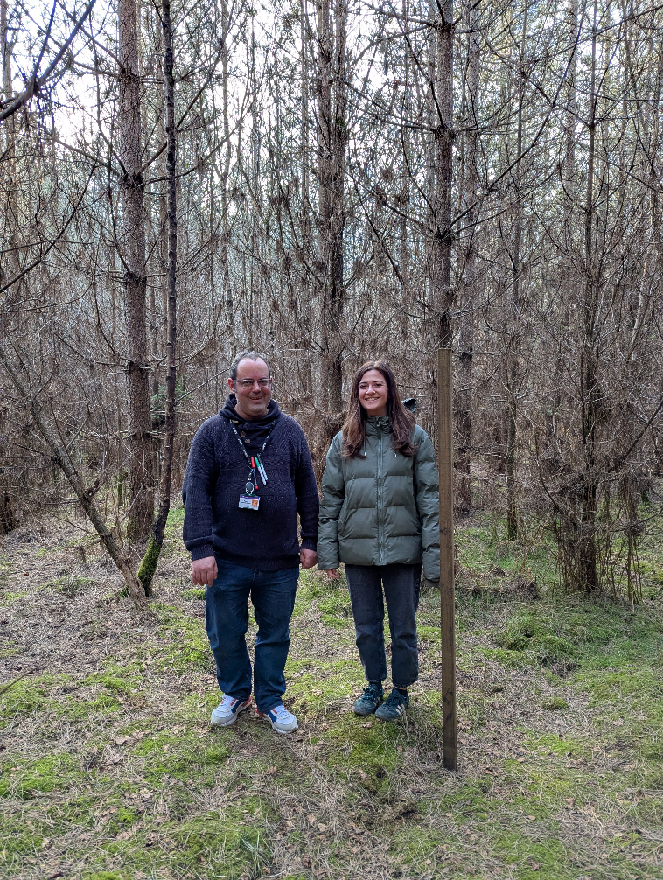
Pedro (right) and Josephine (left) at Forest Research UK, Alice Holt, Wrecclesham, Farnham

